Jevonte Frederick
6/17/2026
SNHU
Artifact Two
For this artifact, I enhanced a project from a computer science course in mobile application development for Android OS. It was first developed back in April of this year. It was a project where I developed an event tracking application that utilizes a database to store user logins and app data. The complexity of the app, and the required attention to detail of user-oriented UI makes it a good artifact for my ePortfolio. It shows creativity, organization, and UI/graphic design skills in the app’s design and code. It also shows my experience and capability of applying to the high-demand industry of mobile development. Since so much of the world leans on mobile devices in the modern day, the artifact of a working Android app showcases my potential as a mobile app developer or even a quality tester of mobile software.
My enhancements to the app completed its intended functionality to issue notifications. A minimum requirement of the original project was to request message permission and send notifications from the app. My enhancement has added this functionality by issuing notifications of events with SMS permission on their stored date. I accomplished this by using a PriorityQueue data structure with a custom comparator to sort events by their value of time in milliseconds, as shown below: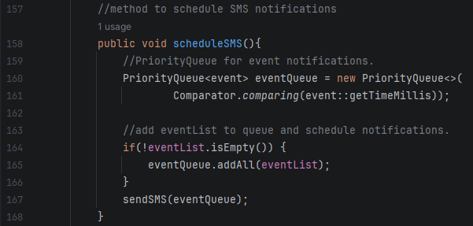
The timeMillis value of each event equates to its entered date converted to time in milliseconds to determine the notification message delay. The queue is then used to schedule SMS notifications with the workManager class by their priority of time until the event’s date. This was not in my original artifact, which only sent a test notification, so I implemented a time variable for event objects to sort them accordingly. I also enhanced the SMS messages to send a specific message with the events names, as shown below:
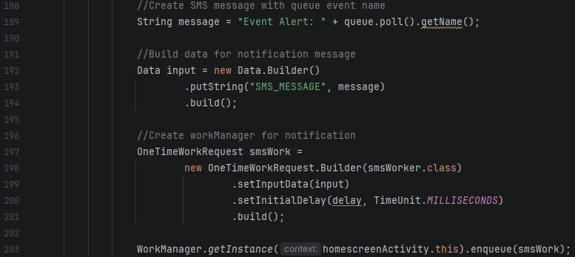
In this snippet, my enhancement uses a String variable that gets the name of the next event in the PriorityQueue. I then build the data for the SMS notification message and use the workManager to enqueue the message with a delay to send on the event date. I additionally changed the code for the display to sort the list of events by date:
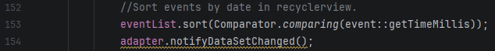
The eventList is used to adapt events stored in the database to display in the UI. Sorting it by the event TimeMillis orders events by date instead of creation order. This introduces scheduling notifications and more organized information display to the app. This does not change how they are stored in the apps database and only effects how they are displayed in the UI so that events are shown in date order.
I made additional enhancements by refactoring or removing unused code. Incomplete code and unused dependencies are a security vulnerability, so I prioritized those in my artifact. An example I did was refactoring the code to log in to the app in mainActivity.java to a method that login() and register() call. Here is the snippet:
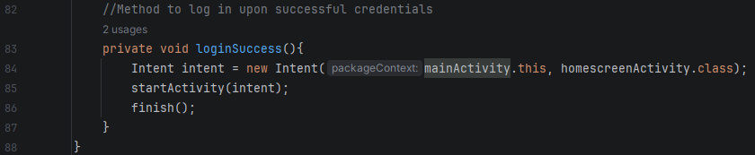
Both login and register call this method as both had similar code to log in to the app. This is an example of my attention to detail in code design to refactor redundant code whenever possible to maximize readability. I also cleaned up the code to log out on each screen after the login screen to log the user out with an alert dialog box. Originally, I left this code incomplete with logout functionality that was not user-friendly. Now, pressing the user icon prompts the user to logout. I also added confirmation to addEventActivity.java that will notify the user to cancel the event entry if any of the fields have information. Here is an example of the confirmation code:
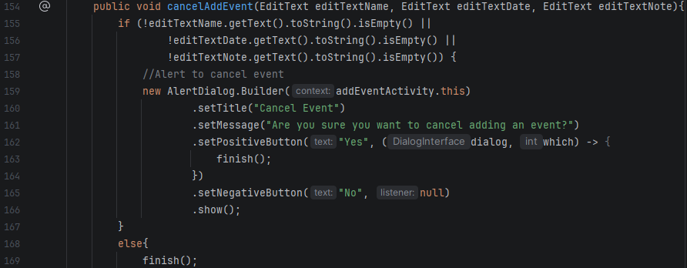
This snippet shows my added user confirmation. It ensures that if text entry objects for name, date, or notes are not empty, a dialog will ask the user to confirm canceling the operation. If nothing is entered, the user can cancel and return to the previous screen without warning. Features like this are important to the user experience in a mobile app because misinputs leading to lost data can be frustrating. Input confirmation is best practice to ensure user-minded UI design for a successful app.
With this artifact enhancement, I believe I have accomplished the outcomes of developing with a security mindset. This is because I approached a large part of this enhancement with the need to fix unused or placeholder code from the artifact. Developing with a security mindset involves designing with vulnerabilities and design flaw mitigation in mind, which is what I highlighted in the enhancements of this artifact. Now, my mobile app is more functionally stable with more user input validation and less leftover code of incomplete features. I also achieved designing and evaluating computing solutions to solve a given problem. The problem was that a core useful feature of this artifact was incomplete in its original version and did not have a clear solution at the time. I was motivated to enhance an already complex project and implement a feature it should have to be a valuable piece of software. Furthermore, this artifact most importantly shows my skills in determination and iteration. The functionality of event notifications was a particularly difficult part of developing this artifact. Based on my research and networking, getting a mobile app to have detailed notifications is a somewhat advanced step in mobile app development. Despite this, I was committed to using my knowledge of data structures to design a solution to this challenge using a PriorityQueue and grow as a potential mobile application developer. I ultimately managed to iterate on the app with the added feature of working SMS notifications, better organization of data in the app, and more user-oriented input confirmation. From this, I can continue to build the app and show my ability as a computer scientist to surpass previous obstacles and learn novel solutions and developer ideas.
Overall, modifying this artifact was challenging. Since the app has so many moving parts, implementing features in the app requires planning and design. Implementing a timeMillis variable for event objects requires refactoring the database and activity methods that use the object. Another challenge was getting SMS message notifications to work. I had to find a way to test that messages were sent on their stored dates which required me to manually change the date of the phone emulator. This was notably cumbersome on the emulator. Additionally, Android Studio is a difficult IDE to use. It is prone to having Gradle errors and significant slowdown and conflicts more than other IDEs I have used. I had to utilize my desktop to run the IDE reliably but was still met with challenges in the emulator with performance bugs. Despite this, a computer scientist must persevere and find workarounds to technical difficulties. Persistence is a driving factor in being a notable professional.
In all, developing apps with Android Studio is very engaging. The complexity of keeping an app’s design and code together is extremely rewarding. This enhancement also gave me more experience with handling date Strings in Java. I do not work with them often, so trying to parse time from event dates was a good refresher. On top of this, it was good to further develop this application to reinforce my knowledge of app development using Android Studio.

